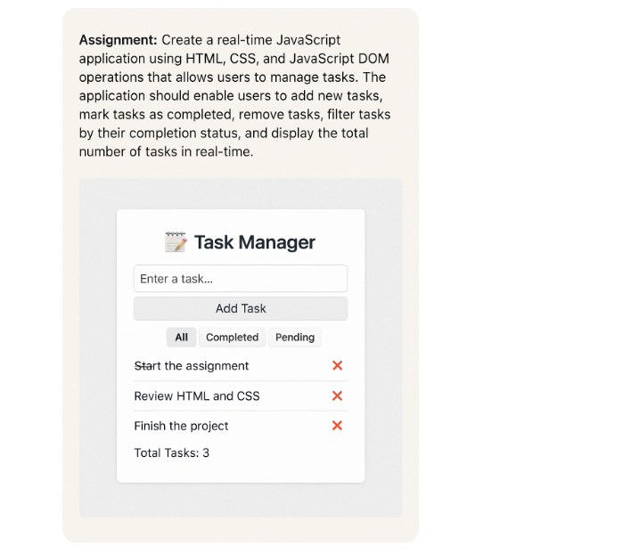

Apply good look and feel for this page using css.

